**Lab Report. 02**

**Subject: Computer Graphics Lab**



Submitted to: Dr. Junaid

Submitted by: Nayab Ashraf (RC-299)

**Date of Submission: 18 September, 2024**

National University of Modern Languages, Department of Computer Science, Rawalpindi Campus.

**Task 01:**

**Implement Quiz-1 theory.**

a)

#include<windows.h>

#include <GL/gl.h>

#include <gl/glut.h>

void myInit()

{

glClearColor(1.0, 1.0, 1.0, 0.0);

glPointSize(10.0);

glMatrixMode(GL_MODELVIEW);

glLoadIdentity();

gluOrtho2D(0.0, 5.0, 0.0, 5.0);

}

void Display()

{

glClear(GL_COLOR_BUFFER_BIT);

//glLineWidth(5);

glColor3f(0.0, 0.0, 0.0);

glBegin(GL_LINES);

glVertex2f(1.0, 1.0);

glVertex2f(4.0, 1.0);

glVertex2f(1.0, 2.0);

glVertex2f(4.0, 2.0);

glVertex2f(1.0, 3.0);

glVertex2f(4.0, 3.0);

glVertex2f(1.0, 4.0);

glVertex2f(4.0, 4.0);

glEnd();

glFlush();

}

int main(int argc, char** argv)

{

glutInit(&argc, argv);

glutInitDisplayMode(GLUT_SINGLE);

glutInitWindowSize(5, 5);

glutInitWindowPosition(0, 0);

glutCreateWindow("First Graphic Code");

myInit();

glutDisplayFunc(Display);

glutMainLoop();

}

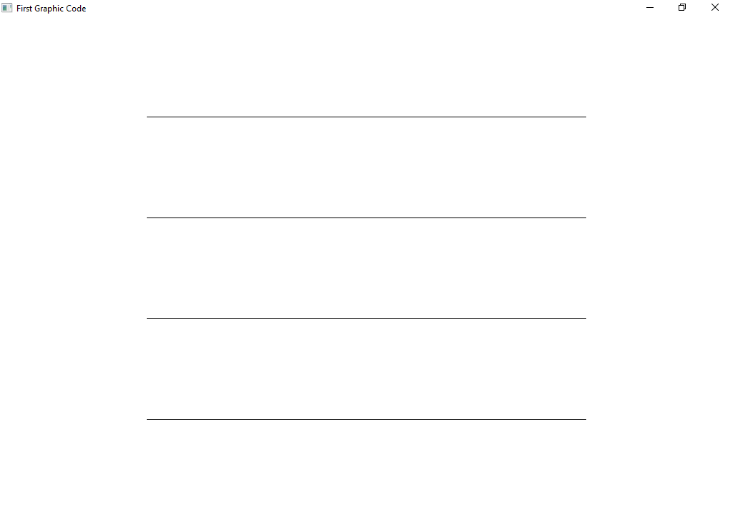

b)

#include<windows.h>

#include <GL/gl.h>

#include <gl/glut.h>

void myInit()

{

glClearColor(1.0, 1.0, 1.0, 0.0);

glPointSize(10.0);

glMatrixMode(GL_MODELVIEW);

glLoadIdentity();

gluOrtho2D(0.0, 5.0, 0.0, 5.0);

}

void Display()

{

glClear(GL_COLOR_BUFFER_BIT);

//glLineWidth(5);

glColor3f(0.0, 0.0, 0.0);

glBegin(GL_LINE_STRIP);

glVertex2f(1.0, 1.0);

glVertex2f(4.0, 1.0);

glVertex2f(1.0, 2.0);

glVertex2f(4.0, 2.0);

glVertex2f(1.0, 3.0);

glVertex2f(4.0, 3.0);

glVertex2f(1.0, 4.0);

glVertex2f(4.0, 4.0);

glEnd();

glFlush();

}

int main(int argc, char** argv)

{

glutInit(&argc, argv);

glutInitDisplayMode(GLUT_SINGLE);

glutInitWindowSize(5, 5);

glutInitWindowPosition(0, 0);

glutCreateWindow("First Graphic Code");

myInit();

glutDisplayFunc(Display);

glutMainLoop();

}

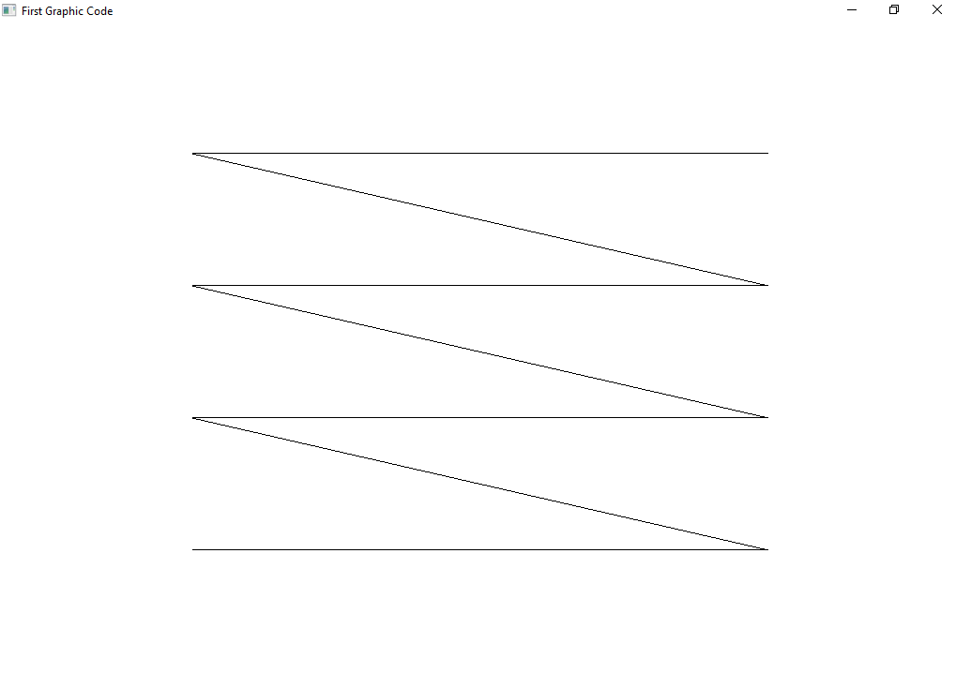

c)

#include<windows.h>

#include <GL/gl.h>

#include <gl/glut.h>

void myInit()

{

glClearColor(1.0, 1.0, 1.0, 0.0);

glPointSize(10.0);

glMatrixMode(GL_MODELVIEW);

glLoadIdentity();

gluOrtho2D(0.0, 5.0, 0.0, 5.0);

}

void Display()

{

glClear(GL_COLOR_BUFFER_BIT);

//glLineWidth(5);

glColor3f(0.0, 0.0, 0.0);

glBegin(GL_LINE_LOOP);

glVertex2f(1.0, 1.0);

glVertex2f(4.0, 1.0);

glVertex2f(1.0, 2.0);

glVertex2f(4.0, 2.0);

glVertex2f(1.0, 3.0);

glVertex2f(4.0, 3.0);

glVertex2f(1.0, 4.0);

glVertex2f(4.0, 4.0);

glEnd();

glFlush();

}

int main(int argc, char** argv)

{

glutInit(&argc, argv);

glutInitDisplayMode(GLUT_SINGLE);

glutInitWindowSize(5, 5);

glutInitWindowPosition(0, 0);

glutCreateWindow("First Graphic Code");

myInit();

glutDisplayFunc(Display);

glutMainLoop();

}

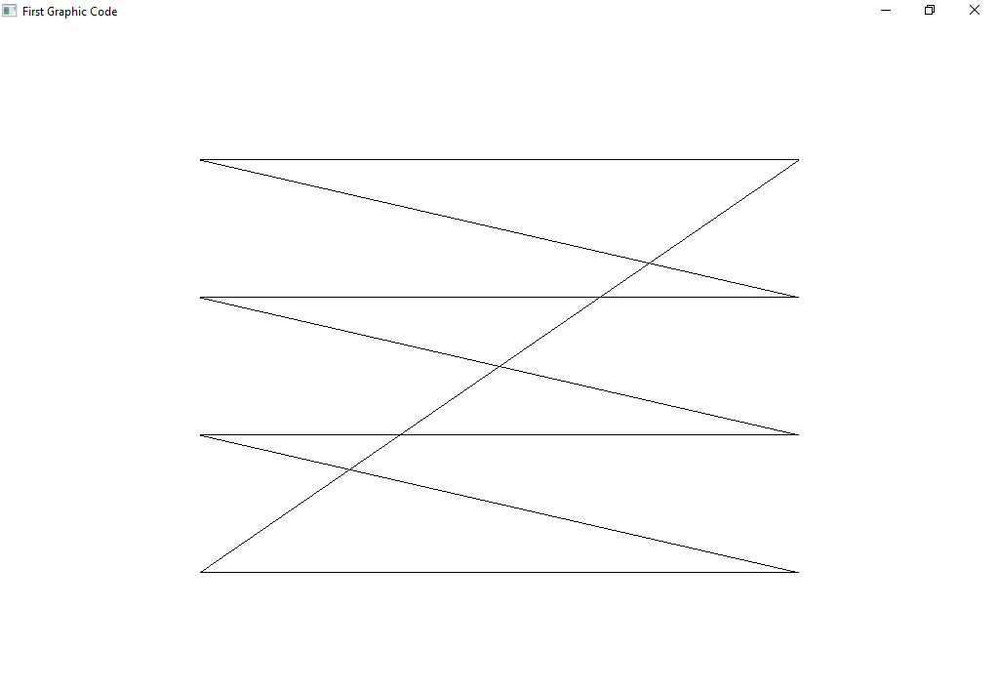

**Task 02:**

Draw a line (0, 0, 50, 50) in a window of size 700x500 and different orthogonal setting.

#include<windows.h>

#include <GL/gl.h>

#include <gl/glut.h>

void myInit()

{

glClearColor(1.0, 1.0, 1.0, 0.0);

glPointSize(40.0);

glMatrixMode(GL_MODELVIEW);

glLoadIdentity();

gluOrtho2D(0.0, 150.0, 0.0, 150.0);

}

void Display()

{

glClear(GL_COLOR_BUFFER_BIT);

glLineWidth(5);

glColor3f(1.0, 0.0, 0.0);

glBegin(GL_LINES);

glVertex2f(0.0, 0.0);

glVertex2f(50.0, 50.0);

glEnd();

glFlush();

}

int main(int argc, char** argv)

{

glutInit(&argc, argv);

glutInitDisplayMode(GLUT_SINGLE);

glutInitWindowSize(700, 500);

glutInitWindowPosition(0, 0);

glutCreateWindow("First Graphic Code");

myInit();

glutDisplayFunc(Display);

glutMainLoop();

}

gluOrtho2D(0.0, 150.0, 0.0, 150.0);

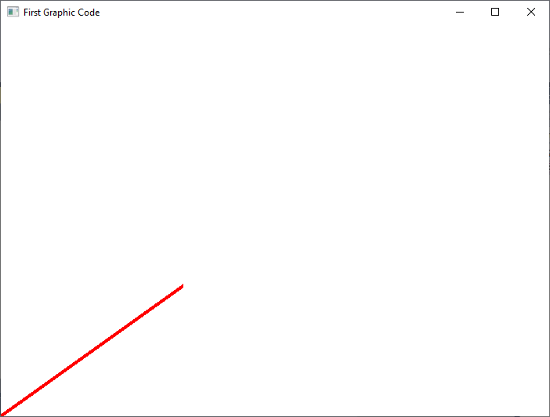

gluOrtho2D(0.0, 80.0, 0.0, 80.0);

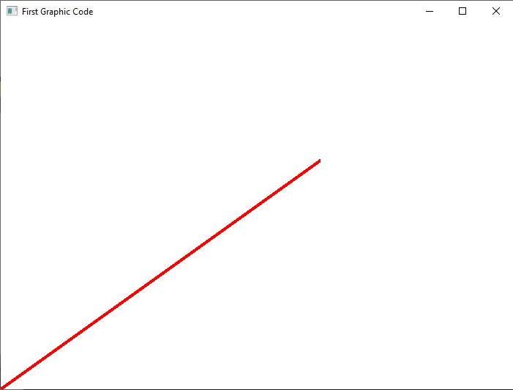

gluOrtho2D(-50.0, 80.0, -50.0, 80.0);

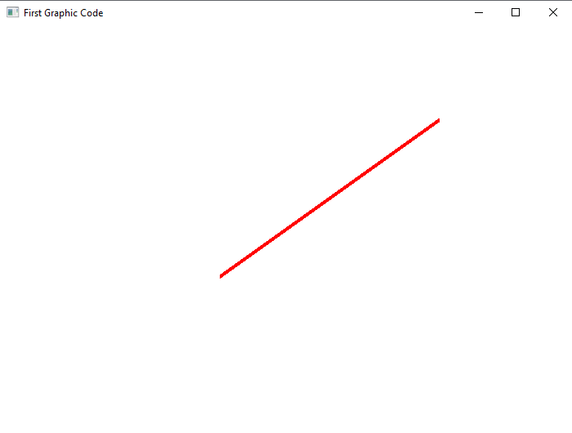

**Task 03:**

Write a function that drawsLine() that takes 4 parameters and draws a line.

void drawLine(GLint x1, GLint y1, GLint x2, GLint y2)

{

glBegin(GL_LINES);

glVertex2i(x1, y1);

glVertex2i(x2, y2);

glEnd();

}

#include<windows.h>

#include <GL/gl.h>

#include <gl/glut.h>

void myInit()

{

glClearColor(1.0, 1.0, 1.0, 0.0);

glPointSize(40.0);

glMatrixMode(GL_MODELVIEW);

glLoadIdentity();

gluOrtho2D(0.0, 80.0, 0.0, 80.0);

}

void drawLine(GLint x1, GLint y1, GLint x2, GLint y2)

{

glBegin(GL_LINES);

glVertex2i(x1, y1);

glVertex2i(x2, y2);

glEnd();

}

void Display()

{

glClear(GL_COLOR_BUFFER_BIT);

glLineWidth(5);

glColor3f(1.0, 0.0, 0.0);

drawLine(0, 0, 50, 50);

glFlush();

}

int main(int argc, char** argv)

{

glutInit(&argc, argv);

glutInitDisplayMode(GLUT_SINGLE);

glutInitWindowSize(700, 500);

glutInitWindowPosition(0, 0);

glutCreateWindow("First Graphic Code");

myInit();

glutDisplayFunc(Display);

glutMainLoop();

}

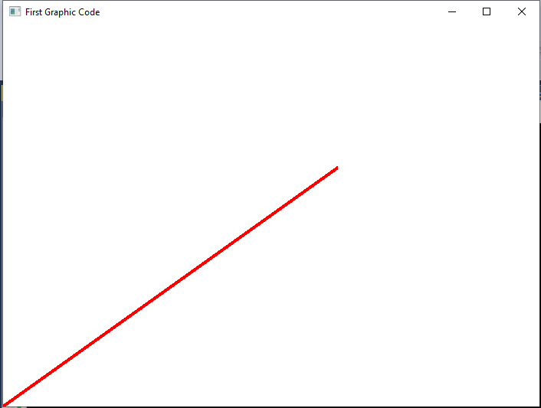

**Task 04:**

Draw diagrams.

#include<windows.h>

#include <GL/gl.h>

#include <gl/glut.h>

void myInit()

{

glClearColor(1.0, 1.0, 1.0, 0.0);

glPointSize(40.0);

glMatrixMode(GL_MODELVIEW);

glLoadIdentity();

gluOrtho2D(0.0, 500.0, 0.0, 500.0);

}

void drawLine(GLint x1, GLint y1, GLint x2, GLint y2)

{

glBegin(GL_LINES);

glVertex2i(x1, y1);

glVertex2i(x2, y2);

glEnd();

}

void Display()

{

glClear(GL_COLOR_BUFFER_BIT);

glLineWidth(5);

glColor3f(1.0, 0.0, 0.0);

drawLine(50, 100, 50, 300);

drawLine(50, 300, 250, 300);

drawLine(250, 300, 250, 250);

drawLine(250, 250, 100, 250);

drawLine(100, 250, 100, 200);

drawLine(100, 200, 200, 200);

drawLine(200, 200, 200, 170);

drawLine(200, 170, 100, 170);

drawLine(100, 170, 100 , 100);

drawLine(100, 100, 50, 100);

glFlush();

}

int main(int argc, char** argv)

{

glutInit(&argc, argv);

glutInitDisplayMode(GLUT_SINGLE);

glutInitWindowSize(500, 500);

glutInitWindowPosition(0, 0);

glutCreateWindow("First Graphic Code");

myInit();

glutDisplayFunc(Display);

glutMainLoop();

}

